Adding vitamin D to food saves lives and reduces health costs in gloomy countries, scientists say

PUBLISHED : Thursday, 16 February, 2017, 9:33am

UPDATED : Thursday, 16 February, 2017, 8:59pm

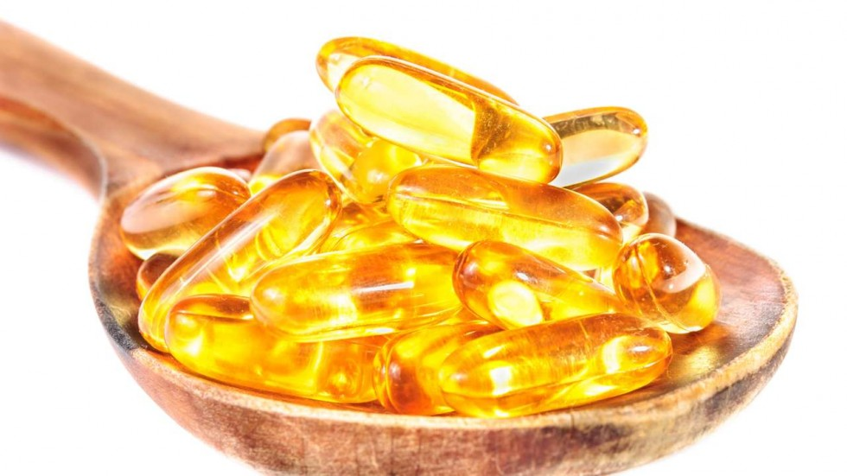

[](http://www.scmp.com/author/guardian-0)

[**The Guardian**](http://www.scmp.com/author/guardian-0)

9SHARE

[Print](http://www.scmp.com/print/news/world/europe/article/2071353/adding-vitamin-d-food-saves-lives-and-reduces-health-costs-gloomy)[Email](http://www.scmp.com/news/world/europe/article/2071353/adding-vitamin-d-food-saves-lives-and-reduces-health-costs-gloomy)

Adding vitamin D to food would reduce deaths and significantly cut healthcare costs in countries such as Britain, say the authors of a major global study that shows it can reduce the risk of colds, flu and other dangerous infections such as pneumonia.

A UK government advisory committee on nutrition has already warned of the low levels of the so-called “sunshine vitamin” in the British population and recommended food fortification as a possible course of action. In the US, for example, milk is fortified with vitamin D.

A study published in the *British Medical Journal* should add persuasive evidence in favour of fortification, argues its lead author. “The results are likely to change the cost/benefit analysis significantly,” said Adrian Martineau, clinical professor of respiratory infection and immunity at Queen Mary University of London.

Many studies have tried to discover whether the increase in colds and flu in the winter is partly down to a lack of sunlight producing vitamin D in the body, but they have had mixed results. The team from Queen Mary argue that their work settles the question because they have reanalysed and pooled the raw data from 25 clinical trials involving about 11,000 patients from 14 countries. The studies that found no benefit had usually given people a large one-off dose of vitamin D rather than regular supplements.

Martineau and his team say their results show a significant but modest benefit for everybody who takes vitamin D daily or weekly, but a more substantial benefit for those who have low levels of it in their bodies. These may be people who do not get outside very much, cover themselves against the sun or for religious reasons, or have dark skins which absorb less sunlight. It is hard to get enough vitamin D from food – it is in oily fish and shiitake mushrooms, but not much else.

Taking a regular supplement halved the rate of respiratory infections in people with the lowest levels of vitamin D, below 25 nanomoles a litre (nmol/L). But it also cut infections by 10 per cent among those with higher vitamin D levels.

Respiratory infections, which can include flu, bronchitis and pneumonia, take a big toll on the nation’s health. About 70 per cent of the UK population get one respiratory infection in any year, with 25 per cent going to the GP. They are the most common reason for a GP consultation and days off work. More than 50 per cent end up with a prescription for antibiotics, which is inappropriate because they are usually caused by a virus. These infections are responsible for 300,000 hospitalisations a year in the UK and about 38,000 people die. Globally they caused an estimated 2.65 million deaths in 2013.

Top of Form

Bottom of Form

The Queen Mary researchers calculate that daily or weekly supplements of vitamin D would mean 3.25 million fewer people in the UK having at least one respiratory infection a year, assuming a population of 65 million.

“Vitamin D fortification of foods provides a steady, low-level intake of vitamin D that has virtually eliminated profound vitamin D deficiency in several countries,” said Martineau.

“By demonstrating this new benefit of vitamin D, our study strengthens the case for introducing food fortification to improve vitamin D levels in countries such as the UK where profound vitamin D deficiency is common.”

Although the authors consider the case proven, scientists are still divided. Mark Bolland from the University of Auckland and Alison Avenell from the University of Aberdeen say in an editorial in the BMJ that large randomised controlled trials – comparing people taking vitamin D with others who do not – are still needed.

“Current evidence does not support the use of vitamin D supplementation to prevent disease, except for those at high risk of osteomalacia (weak bones and muscles due to low blood vitamin D levels, currently defined as less than 25 nmol/L),” they write.

Others applaud the Queen Mary study.

Martin Hewison, professor of molecular endocrinology at the University of Birmingham, said he agreed the case for vitamin D supplementation against respiratory infections was proven.

“This may be particularly important for people in the UK who are at high risk of vitamin D deficiency, particularly in the winter,” he said, adding that higher doses than currently recommended for bone health might be needed and called for more trials. Low levels of vitamin D can cause the bone disease rickets in children.

***This article appeared in the South China Morning Post print edition as:***

*Could adding vitamin D to food reduce deaths?*